NYSSLS Daily Lesson Plan
Instructional Unit:  Weather and Climate –  Air masses, Fronts and Weather  LESSON: ENERGY TRANSFER |  |  |  |  |  | Period(s) of Unit:  2 Periods |  | Date:
Materials/Resources/Links:  Particle Simulation of Thermal Conduction - Javalab  Electromagnetic Waves around of Visible Rays - Javalab  Convection Cells Gizmo : ExploreLearning |  |  |  |  |  |  |  | Course:  Earth and Space Science
Special Notes for Lesson:

ANCHORING PHENOMINON: If the sun drives all weather on Earth, how does it do it?

Standards:
Science and Engineering Practices  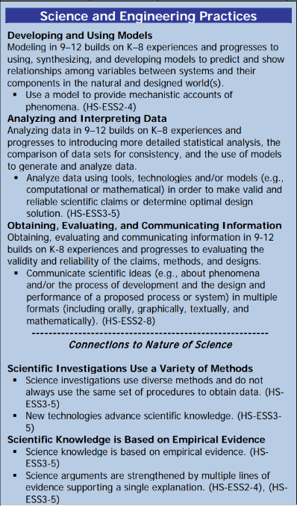 |  |  | Disciplinary Core Idea(s)  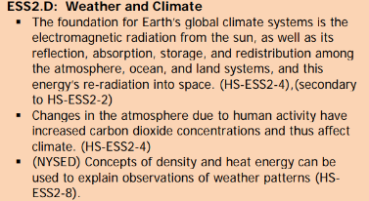 |  |  |  | Cross Cutting Concepts  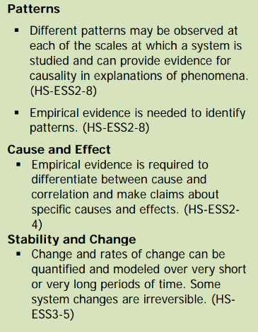
Performance Level
NYS Level 5 | NYS Level 4 |  |  | NYS Level 3 | NYS Level 2 |  |  | NYS Level 1
Collect and analyze global and regional weather data using tools, technologies, and /or models to communicate in multiple formats how the movement and interactions of airmasses result in changes in weather conditions. | Evaluate data and communicate information to explain hoe the movement and interactions of air masses result in changes in weather conditions |  |  | Evaluate data and communicate information to identify patterns of movement and/or the resulting changes in weather conditions. | Use data to identify the patterns of movement or the interactions of air masses and the resulting change in weather conditions  or to identify factors that drive the movement of air masses or from given weather conditions, identify evidence from maps that support these conditions. |  |  | Use data and/or patterns of movement and interactions of air masses to identify the resulting changes in weather conditions or identify one factor that drives the movement of air masses or from those provided, use evidence from maps to account for weather conditions or given weather conditions, identify evidence found on maps that account for one of these conditions.
Clarification Statement  .  Examples of evidence sources could include station models, surface weather maps, satellite images, radar and accepted forecast models. Emphasis should focus on communicating how the uneven heating of the Earth’s surface at frontal boundaries and resulting weather phenomena. |  |  |  |  | Assessment Boundary  Analysis is limited to surface weather maps and general weather patterns associated with High and Low pressure systems
Connection to Anchoring Phenomenon:

Weather is driven by the sun’s energy. Energy needs to be transferred from the sun to the Earth and to the atmosphere by radiation, conduction and convection.

Essential Question(s):
Radiation questions.

Describe how energy is transferred by radiation. Do you know of any other place on Earth where energy is transferred by these means?

How are the different forms of electromagnetic energy different?

Conduction questions

Describe how energy is being transferred in the simulation.

Give examples of this type of energy transfer that you have observed in your life.

Convection questions

Describe the motion of the water when it is heated.

Is there anything else in life that you can think of where heat is transferred in this manner.

Instructional Strategies & Learning Tasks: Engage, Explore, Explain, Elaborate, Evaluate
Engage: images, video clip or data… |  | The sun’s energy is the driving force of all weather on Earth. How does the sun create weather on Earth?
Explore: Students investigate, experiment, hands-on activity…. |  | Students will explore simulations for Radiation, Conduction and Convection.
Explain: Students share their observations and evidence to explain their understanding…possible whole group/class discussion… |  | The class will discuss their findings and relate these forms of energy transfer to their own experiences.
Elaborate: Students apply the science concepts they’ve just learned… |  | The teacher will guide the students to make connections between the forms of energy transfer that they investigated to it’s application in meteorology.
Evaluate (Formative Assessment): Student learning is evaluated. |  | Students will be evaluated with teacher questions as well as a quiz or a test.

Copy and paste student worksheets below:

